The SLR Experience

Contents

Overview 2

Audience 2

Revenue Sources 2

The Virtual SLR 3

How It Works 4

Metering Areas 6

Simulated Metering 6

Running the Virtual Meter 7

# Overview

## Audience

Students

* Use the Virtual SLR to experiment with metering and exposure
* Take quizzes to test your abilities
* Take online courses to learn photography
* Post questions and submit answers
* Rate images, photographers, videos, etc.

Educators

* Use the Virtual SLR to illustrate concepts from your blog, book, or online course
* Link images in the gallery to your website
* Post YouTube videos

Guides

* Gain exposure to your destinations by linking images in the gallery to your website
* Advertise your tours to photographers

Retailers

* Advertise your products and services to SLR photographers

Destinations

* Promote your location by adding images to the Virtual SLR gallery
* Advertise your location

## Revenue Sources

* Online courses
* Advertisement
* Linking to external resources

# The Virtual SLR

The goal of this application is to help students understand the principals of metering and exposure by enabling them to experiment with a virtual SLR camera using real-world images.

The virtual camera works like a real SLR camera letting you change ISO, shutter speed, and aperture settings. You see a meter reading based on these settings for the area you want to meter. Metering can be performed by selecting any of the standard metering areas that are available in the Viewfinder, or by creating your own metering area wherever you want in the scene. These movable metering areas are needed because you can’t move the camera like you would in real life.

Once you have the settings you want you click the shutter release button and see the results of your exposure. You see an actual image taken by the SLR for the exposure you created (no simulated images), and you also see a histogram and a blowout indicator showing areas of the image that are washed out.

This learning environment provides many advantages over traditional methods for learning photography including:

1. You can learn from any computer with an internet connection
2. You don’t spend time or money travelling or buying equipment
3. You don’t struggle with the elements such as rain, wind, heat, and cold
4. The images are much larger than they appear on camera, and you don’t have glare from the sun
5. You can revisit the exact same scene whenever you want

In addition to these advantages over traditional learning, the virtual approach opens up new opportunities for students of photography:

1. Learn how to create an effect by doing it, eg. using overexposure to create angelic portraits
2. Take quizzes where the desired exposure is shown and they try to make it
3. Get familiar with destinations before you go there

## How It Works

You start off by selecting an image from the gallery. The selected image appears in the virtual Viewfinder depicted below.

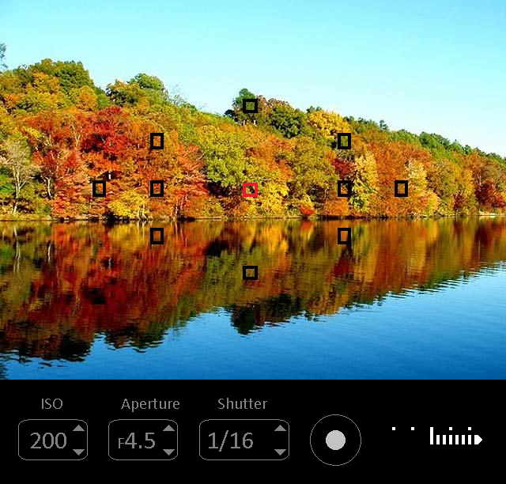

The view finder lets you change ISO, Aperture, Shutter, and the metered area (red border). You can also click on the image to create a custom metered area anywhere you want. The meter reading displays beside the shutter release button. The example above indicates a severely overexposed image which you would expect at mid-day with ISO 200, Aperture 4.5, and a shutter speed of 1/16th of a second (very slow).

Like a real SLR, the image in the view finder does not change when you change settings. The display image is setup to look like it does in real life as you look through the real viewfinder. When you click the Exposure button you see your exposure. This is not a calculated result, it is a real image taken with the SLR for the exposure you selected. This is achieved by creating a wide range of exposures for each image in the gallery. In addition to the image you see the histogram and a highlight indicator that flashes for overexposed areas of the image.

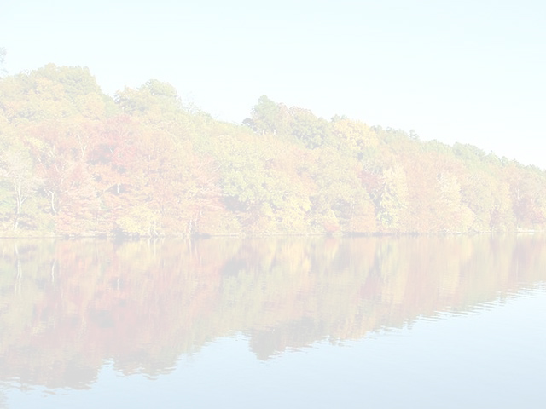

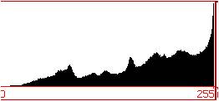 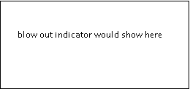

## Metering Areas

The image below shows the location of the metering areas of the Nikon D200 SLR camera. 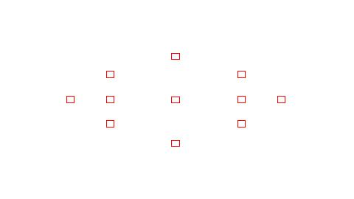

## Simulated Metering

Calculated brightness for metering areas: 0 = black, 50 = neutral, 100 = white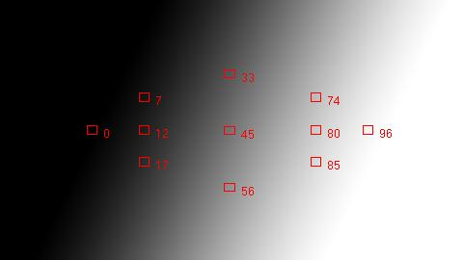

## The Virtual Meter

Each photo in the gallery represents a series of images all taken at different exposures from severely underexposed to severely overexposed. The exposure that best represents the artist’s intent is selected to appear in the gallery.

When an image is selected the viewfinder displays an image that looks like what you see through the viewfinder in real life. In some high-contrast scenes this might require an HDR image since the human eye can detect a wider range of brightness than a camera.

The meter changes based on the settings selected by the student. This is accomplished by selecting the image that corresponds to the virtual exposure. For example, a virtual exposure of F8 and 1/100th second could bring back a real exposure of F4 and 1/200th second because these are equivalent exposures. The brightness of the metered area is then read from the selected image and used to update the meter value.

The process of reading the brightness of a selected area within an image uses custom code developed and calibrated for this project. This was achieved by controlling a light with a dimmer to find the range of brightness that falls within each notch on the meter. For example, neutral can range from 46% to 54% in the software, but remains neutral on the camera’s meter. By reading the brightness of the selected area within the selected image, the meter reading can be looked up and displayed.

This process requires a significant amount of computation, which would make it expensive to perform on demand. The solution to this problem is to limit the positions of the metering areas and calculate them once and store the values in the database. This way the calculations need only be performed once for every metering point in the image. By providing enough metering points the student feels like they can meter anywhere, but they are actually restricted to a grid with many points.